Business Questions

1. Provide a monthly breakdown of artists by number of streams, number of tracks in the weekly top-200 chart and track peak position on spotify in the UK between Mar-2019 and Feb-2020.

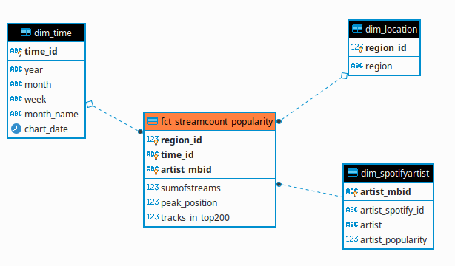

1. Provide a monthly analysis of number of live music events by event type (festival and live concerts), day of week and event start-time in the UK between Mar-2019 and Feb-2020

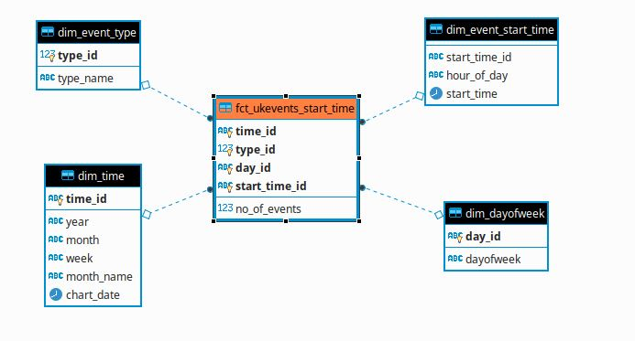

1. Provide monthly analysis of UK live music events showing number of events per artist groups (spotify-trending and others) and event type between Mar-2019 and Feb-2020

